**Project Design Phase-II**

**Data Flow Diagram & User Stories**

|  |  |
| --- | --- |
| Date | 31 January 2025 |
| Team ID | LTVIP2025TMID45663 |
| Project Name | CleanTech: Transforming Waste Management with Transfer Learning |
| Maximum Marks | 4 Marks |

**Data Flow Diagrams:**

A Data Flow Diagram (DFD) is a traditional visual representation of the information flows within a system. A neat and clear DFD can depict the right amount of the system requirement graphically. It shows how data enters and leaves the system, what changes the information, and where data is stored.

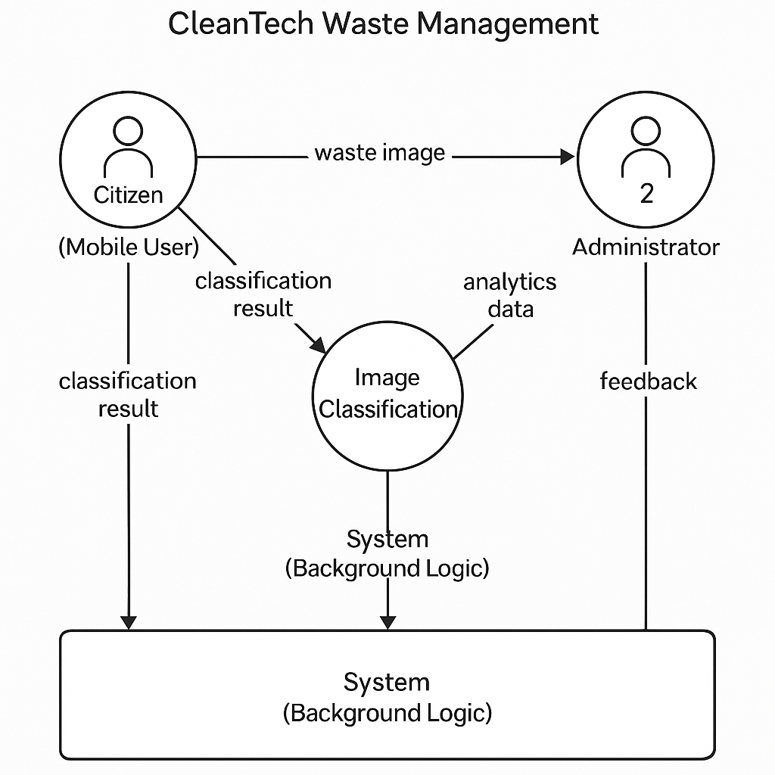

**User Stories**

Use the below template to list all the user stories for the product.

| **User Type** | **Functional Requirement (Epic)** | **User Story Number** | **User Story / Task** | **Acceptance Criteria** | **Priority** | **Release** |
| --- | --- | --- | --- | --- | --- | --- |
| Citizen (Mobile User) | Registration | USN-1 | As a user, I can register on the CleanTech app using email and password | I receive confirmation and can log in to the app | High | Sprint-1 |
| Citizen (Mobile User) | Registration | USN-2 | As a user, I can register using Google authentication | I can log in using Google and access the app dashboard | Medium | Sprint-1 |
| Citizen (Mobile User) | Waste Data Upload | USN-3 | As a user, I can upload an image of waste from my mobile camera | The system accepts image and confirms upload | High | Sprint-1 |
| Citizen (Mobile User) | Dashboard | USN-4 | As a user, I can view the classification result (Recyclable / Non-recyclable) | The waste type is displayed with confidence score | High | Sprint-2 |
| Citizen (Mobile User) | Feedback | USN-5 | As a user, I can give feedback on waste classification result | I get confirmation that feedback is received | Medium | Sprint-2 |
| Administrator | Data Visualization | USN-6 | As an admin, I can view waste classification analytics (bar, pie, map) | Admin dashboard loads charts with data summaries | High | Sprint-2 |
| Administrator | User Management | USN-7 | As an admin, I can view registered users and their activity | User list and activity logs are viewable | Medium | Sprint-3 |
| Administrator | Model Training / Feedback Loop | USN-8 | As an admin, I can view and manage user feedback to retrain model | Model accuracy improves over time with feedback | Medium | Sprint-3 |
| System (Background Logic) | Image Classification | USN-9 | As the system, I classify uploaded waste images using a transfer learning model | System returns recyclable/non-recyclable with confidence level | High | Sprint-2 |
| System (Background Logic) | Data Storage | USN-10 | As the system, I store uploaded images and classification results securely | Data is stored and retrievable | High | Sprint-1 |
| Customer Care Executive | Report Generation | USN-11 | As a customer care executive, I can generate reports of waste data trends | PDF/CSV report generated with classification history | Low | Sprint-4 |